Hinge Theorem

Definition
# Source: AI Source: Provided by: [Data Path: Persons Table -> ID Column: 1, Name_En Column: Motasem Essam] -> From: [ChatGPT] on [7/25/2026]
The Hinge Theorem, also known as the SAS Inequality Theorem, states that if two sides of one triangle are congruent to two sides of another triangle, then the triangle with the larger included angle has the longer third side.
The included angle is the angle formed by the two specified sides.

Simple Definition
# Source: AI Source: Provided by: [Data Path: Persons Table -> ID Column: 1, Name_En Column: Motasem Essam] -> From: [ChatGPT] on [7/25/2026]
If two triangles have two pairs of equal sides, the triangle with the larger angle between those sides has the longer third side.

Main Classification
# Source: AI Source: Provided by: [Data Path: Persons Table -> ID Column: 1, Name_En Column: Motasem Essam] -> From: [ChatGPT] on [7/25/2026]
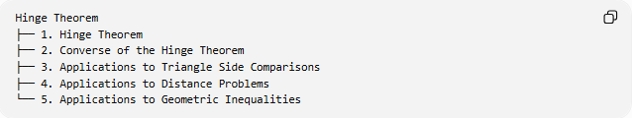
Hinge Theorem
├── 1. Hinge Theorem
├── 2. Converse of the Hinge Theorem
├── 3. Applications to Triangle Side Comparisons
├── 4. Applications to Distance Problems
└── 5. Applications to Geometric Inequalities
These are practical study categories; the two principal theorem statements are the Hinge Theorem and its converse.

Hinge Theorem
# Source: AI Source: Provided by: [Data Path: Persons Table -> ID Column: 1, Name_En Column: Motasem Essam] -> From: [ChatGPT] on [7/25/2026]
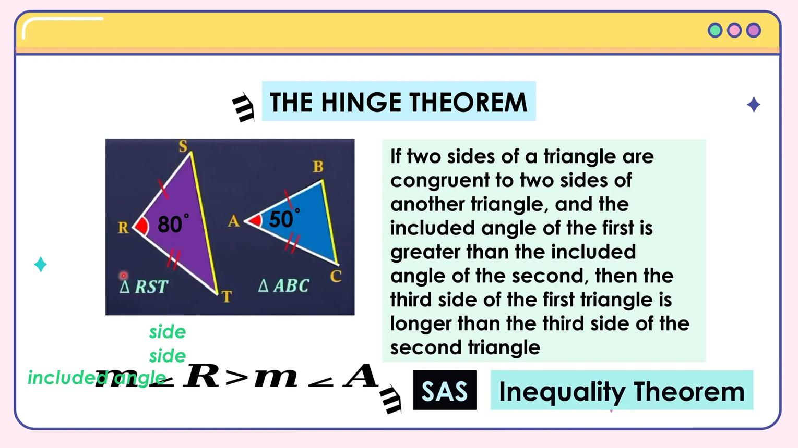
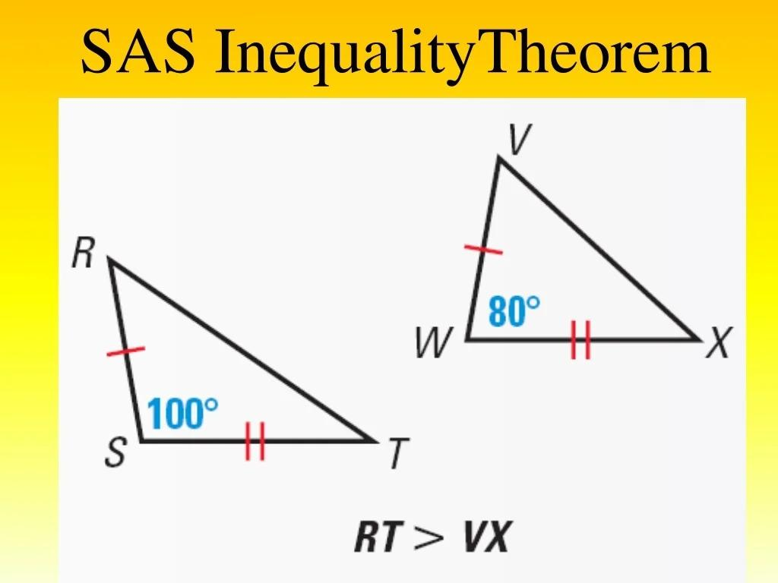
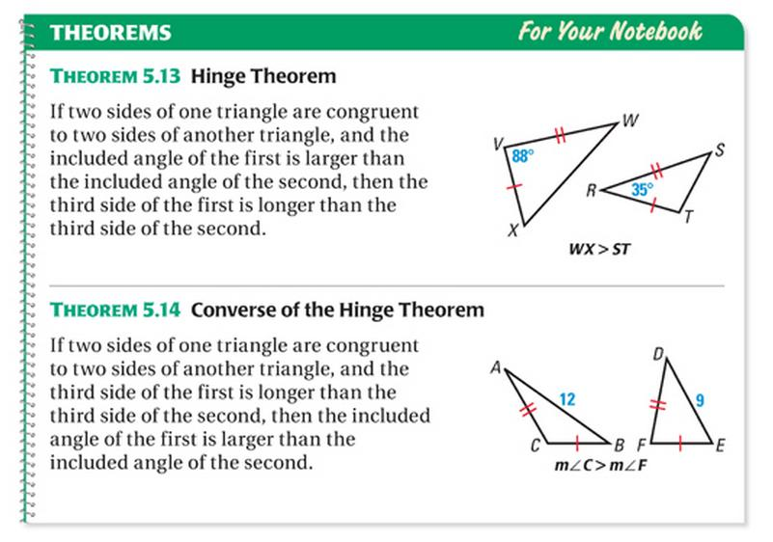
Statement
Suppose triangles $ABC$and $DEF$satisfy:
$$AB=DE$$
$$AC=DF$$
and:
$$m∠A>m∠D$$
Then:
$$\boxed{BC>EF}$$
The sides $AB$and $AC$form the included angle $∠A$. Similarly, $DE$and $DF$form $∠D$.
Example
Suppose two triangles have:
- First triangle: sides $AB=5$, $AC=7$, and included angle $A={90}^{∘}$.
- Second triangle: sides $DE=5$, $DF=7$, and included angle $D={60}^{∘}$.
Because:
$${90}^{∘}>{60}^{∘}$$
the Hinge Theorem tells us:
$$BC>EF$$
We can verify this using the Law of Cosines.
For the first triangle:
$$BC^{2}=5^{2}+7^{2}-2\left(5\right)\left(7\right)\cos{{90}^{∘}}$$
$$BC=\sqrt{74}≈8.60$$
For the second triangle:
$$EF^{2}=5^{2}+7^{2}-2\left(5\right)\left(7\right)\cos{{60}^{∘}}$$
$$EF=\sqrt{39}≈6.24$$
Therefore:
$$\boxed{BC>EF}$$
The larger included angle produces the longer third side when the other two sides remain fixed.

Converse of the Hinge Theorem
# Source: AI Source: Provided by: [Data Path: Persons Table -> ID Column: 1, Name_En Column: Motasem Essam] -> From: [ChatGPT] on [7/25/2026]
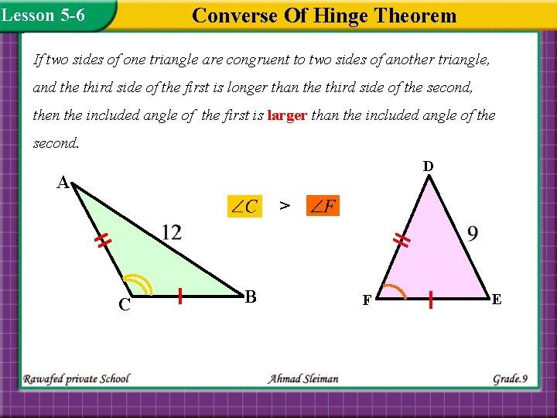
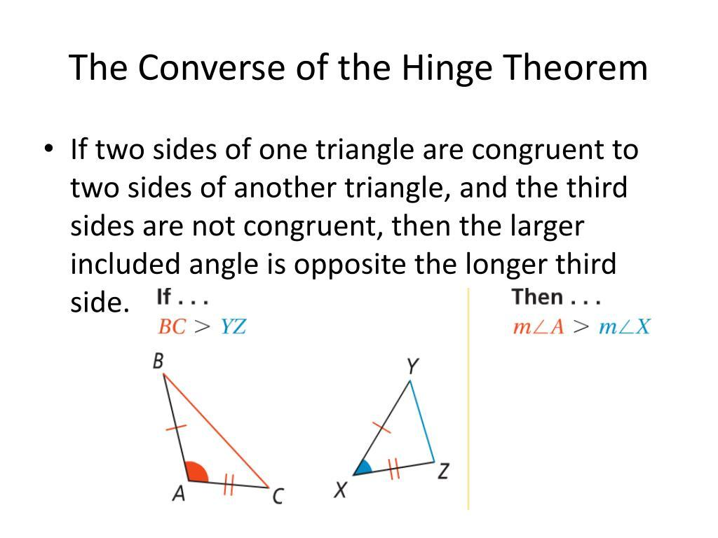
Statement
If two triangles have two pairs of congruent sides, then the triangle with the longer third side has the larger included angle.
Suppose:
$$AB=DE, AC=DF$$
and:
$$BC>EF$$
Then:
$$\boxed{m∠A>m∠D}$$
Example
Suppose two triangles share side lengths of $4$and $6$, but their third sides are $8$and $7$, respectively.
Since:
$$8>7$$
the included angle opposite the third side of length $8$is larger than the included angle opposite the third side of length $7$.
This is the converse of the Hinge Theorem.

Applications
# Source: AI Source: Provided by: [Data Path: Persons Table -> ID Column: 1, Name_En Column: Motasem Essam] -> From: [ChatGPT] on [7/25/2026]
A. Comparing triangle sides
If two sides of two triangles are equal in corresponding pairs, compare the included angles to determine which third side is longer.
B. Comparing angles
If the corresponding first two sides are equal and one third side is longer, use the converse to determine which included angle is larger.
C. Distance problems
Imagine two people walking from the same starting point along paths of equal lengths. If the angle between their paths is larger, the distance between their endpoints is greater.
For example, if both walk 555 metres and 777 metres along two segments, increasing the angle between those segments increases the distance between the endpoints.
D. Geometric inequalities
The theorem provides a way to establish inequalities between side lengths without calculating those lengths exactly.

Why Does the Theorem Work?
# Source: AI Source: Provided by: [Data Path: Persons Table -> ID Column: 1, Name_En Column: Motasem Essam] -> From: [ChatGPT] on [7/25/2026]
The Law of Cosines explains the relationship:
$$c^{2}=a^{2}+b^{2}-2ab\cos{C}$$
When $a$and $b$are fixed, increasing $C$from $0^{∘}$to ${180}^{∘}$decreases $\cos{C}$. Therefore, the value of $c^{2}$, and consequently $c$, increases.
This gives the same conclusion as the Hinge Theorem.

Hinge Theorem vs. Converse
# Source: AI Source: Provided by: [Data Path: Persons Table -> ID Column: 1, Name_En Column: Motasem Essam] -> From: [ChatGPT] on [7/25/2026]
Feature | Hinge Theorem | Converse
Given comparison | Included angles | Third sides
Equal quantities | Two pairs of sides | Two pairs of sides
Conclusion | Compare third sides | Compare included angles
Logical direction | Angle inequality $⇒$side inequality | Side inequality $⇒$angle inequality

Important Conditions
# Source: AI Source: Provided by: [Data Path: Persons Table -> ID Column: 1, Name_En Column: Motasem Essam] -> From: [ChatGPT] on [7/25/2026]
- The triangles must have two pairs of corresponding equal sides.
- The compared angles must be the included angles, between those sides.
- A larger included angle produces a longer third side.
- The converse compares third sides to determine the included angles.
- If the included angles are equal and the two pairs of sides are equal, the triangles are congruent by SAS, so their third sides are equal.

Key Formulas
# Source: AI Source: Provided by: [Data Path: Persons Table -> ID Column: 1, Name_En Column: Motasem Essam] -> From: [ChatGPT] on [7/25/2026]
Hinge Theorem:
$$AB=DE, AC=DF, ∠A>∠D$$
implies:
$$\boxed{BC>EF}$$
Converse:
$$AB=DE, AC=DF, BC>EF$$
implies:
$$\boxed{∠A>∠D}$$
Law of Cosines:
$$\boxed{c^{2}=a^{2}+b^{2}-2ab\cos{C}}$$

Conclusion
# Source: AI Source: Provided by: [Data Path: Persons Table -> ID Column: 1, Name_En Column: Motasem Essam] -> From: [ChatGPT] on [7/25/2026]
The Hinge Theorem compares the third sides of two triangles when two pairs of corresponding sides are equal. The triangle with the larger included angle has the longer third side. Its converse reverses this relationship: the triangle with the longer third side has the larger included angle.

